2 Digital Image Fundamentals

2.1 Elements of Visual Perception

- Although the field of digital image processing is built on a foundation of mathematics, human intuition and analysis often play a role in
the choice of one technique versus another, and this choice often is made based on subjective, visual judgments.
- We are interested in learning the physical limitations of human vision in terms of factors that also are used in our work with digital images.

Structure of the Human Eye
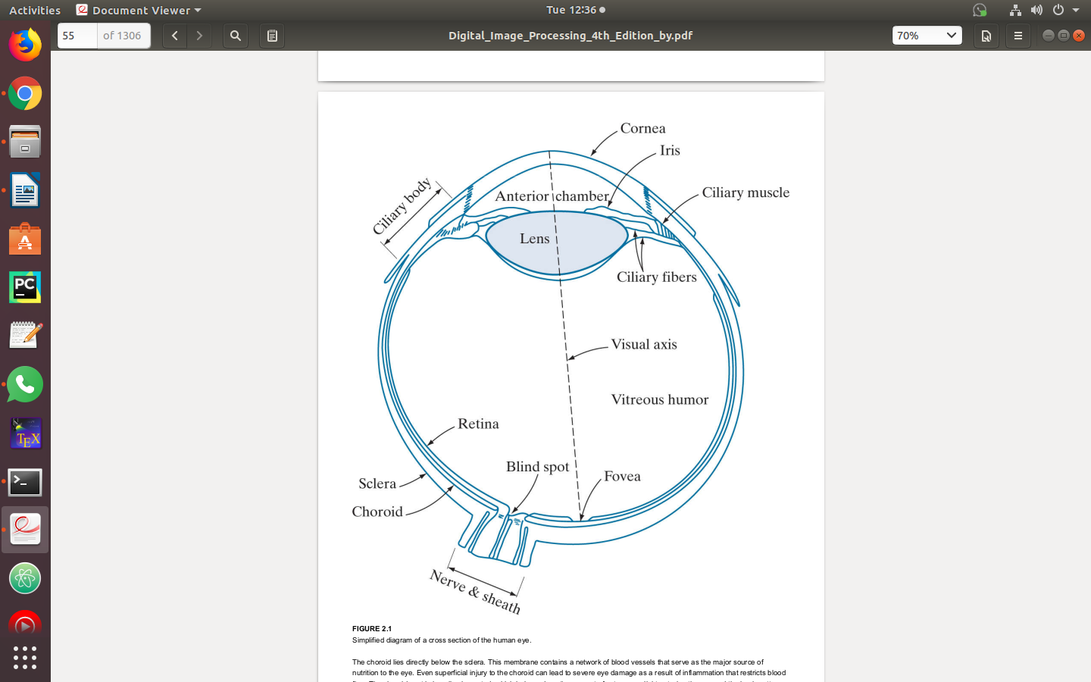
- The eye is nearly sphere, about 20mm in diameter, with three membranes: the cornea and sclera outer cover, the choroid, and the retina
- Cone: 6 to 7 millions in each eye, located primarily in the central portion of the retina – fovea, and highly sensitive to color. Cone vision – photopic or bright-light vision.
- Rod: 75 to 150 million, distributed over the retina. Rods capture an overall image of the field of view, and are not involved in color vision. Rod vision – scotopic or dim-light vision.
- Blind spot: The region where optic nerve emerges from the eye, and is absent of any receptors.

Image Formation in the Eye
- In an ordinary photographic camera, the lens has a fixed focal length. Focusing at various distances is achieved by varying the distance between the lens and the imaging plane, where the film (or imaging chip in the case of a digital camera) is located.
- In the human eye, the converse is true; the distance between the center of the lens and the imaging sensor (the retina) is fixed, and the focal length needed to achieve proper focus is obtained by varying the shape of the lens.
- The fibers in the ciliary body accomplish this by flattening or thickening the lens for distant or near objects, respectively
- The geometry in Fig. 2.3 illustrates how to obtain the dimensions of an image formed on the retina. For example, suppose that a person is looking at a tree 15 m high at a distance of 100 m.
- Letting h denote the height of that object in the retinal image, the geometry of Fig. 2.3 yields 15/100 = h/17 or h = 2.5 mm.
- The retinal image is focused primarily on the region of the fovea
- Perception then takes place by the relative excitation of light receptors, which transform radiant energy into electrical impulses that ultimately are decoded by the brain.

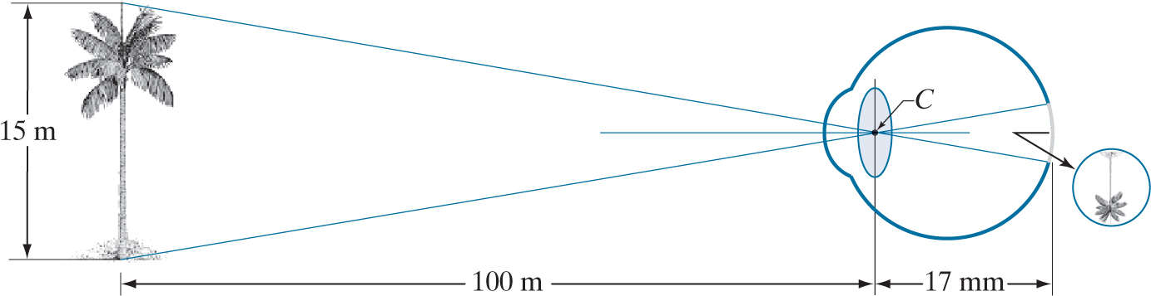
Brightness Adaptation and Discrimination
- Because digital images are displayed as sets of discrete intensities, the eye’s ability to discriminate between different intensity levels is an important consideration in presenting image processing results
- Experimental evidence indicates that subjective brightness (intensity as perceived by the human visual system) is a logarithmic function of the light intensity incident on the eye.
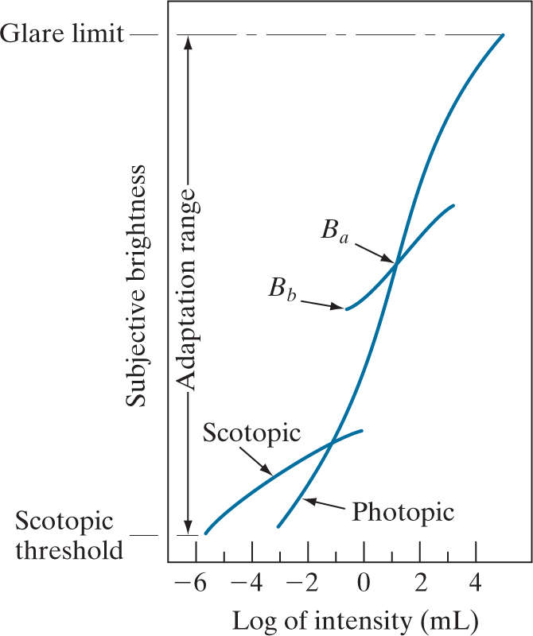
- Figure 2.4 , a plot of light intensity versus subjective brightness, illustrates this characteristic. The long solid curve represents the range of intensities to which the visual system can adapt.
- The long solid curve represents the range of intensities to which the visual system can adapt.
- The key point in interpreting the impressive dynamic range depicted in Fig. 2.4 is that the visual system cannot operate over such a range simultaneously
- Rather, it accomplishes this large variation by changing its overall sensitivity, a phenomenon known as brightness adaptation.
- For a given set of conditions, the current sensitivity level of the visual system is called the brightness adaptation level, which may correspond, for example, to brightness in Fig. 2.4
- The short intersecting curve represents the range of subjective brightness that the eye can perceive when adapted to this level
- The ability of the eye to discriminate between changes in light intensity at any specific adaptation level is of considerable interest
- A classic experiment used to determine the capability of the human visual system for brightness discrimination consists of having a subject look at a flat, uniformly illuminated area large enough to occupy the entire field of view.
- This area typically is a diffuser,illuminated from behind by a light source, I, with variable intensity.
- To this field is added an increment of illumination, Δl ,in the form of a short-duration flash that appears as a circle in the center of the uniformly illuminated field, as Fig. 2.5 shows.

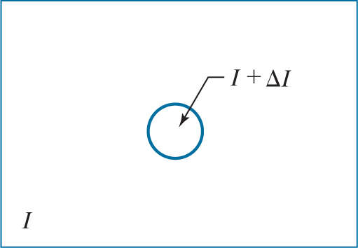

FIGURE 2.5 Basic experimental setup used to characterize brightness discrimination.
- If Δ is not bright enough, the subject says “no,” and yes when is strong enough
- The quantity Δl_{c}/l_{c}, where Δl_{c} is the increment of illumination discriminable 50% of the time with background illumination I, is called the Weber ratio
- A small change in Δl_{c}/l_{c} means that a small percentage change in intensity is discriminable.
- Conversely, a large value of Δl_{c}/l_{c} means that a large percentage change in intensity is required for the eye to detect the change. This represents “poor” brightness discrimination
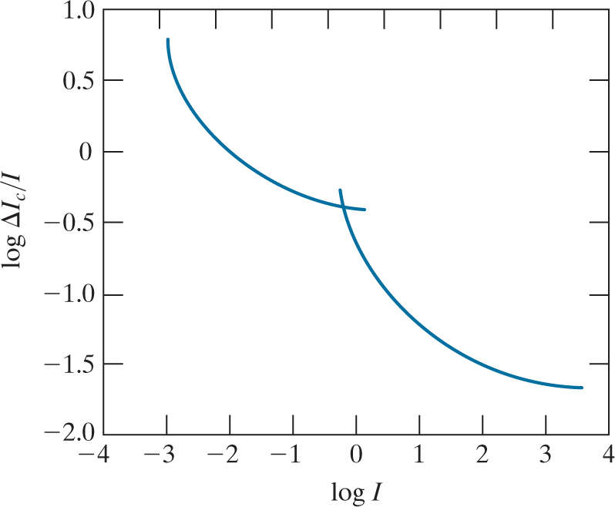
- FIGURE 2.6 A typical plot of the Weber ratio as a function of intensity.
- A plot of Δl_{c}/l_{c} as a function of log I has the characteristic shape shown in Fig. 2.6
- This curve shows that brightness discrimination is poor (the Weber ratio is large) at low levels of illumination, and it improves significantly (the Weber ratio decreases) as background illumination increases.
- The two branches in the curve reflect the fact that at low levels of illumination vision is carried out by the rods, whereas, at high levels, vision is a function of cones
- If the background illumination is held constant and the intensity of the other source, instead of flashing, is now allowed to vary incrementally from never being perceived to always being perceived, the typical observer can discern a total of one to two dozen different intensity changes
- Two phenomena demonstrate that perceived brightness is not a simple function of intensity. The first is based on the fact that the visual system tends to undershoot or overshoot around the boundary of regions of different intensities
- Figure 2.7(a) shows a striking example of this phenomenon. Although the intensity of the stripes is constant [see Fig. 2.7(b) ], we actually perceive a brightness pattern that is strongly scalloped near the boundaries, as Fig. 2.7(c) shows.

